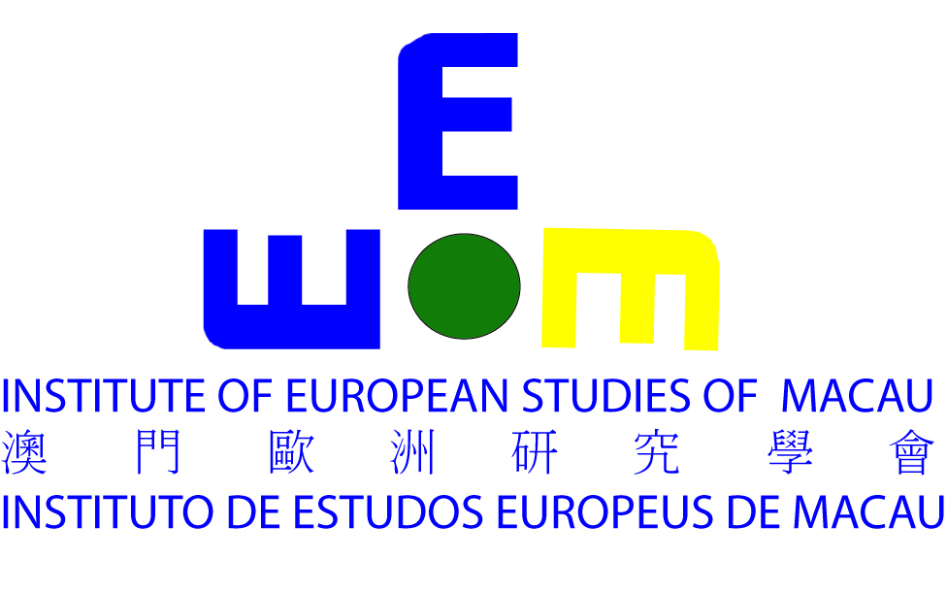
2020-2023 Continuing Education Program Registration Form
2020-2023“ 持續進修發展計劃 ” 學 員 報 名 表
- Name of Institute機構名稱: Institute of European Studies of Macau

- Course No. 課程/證照考試編號: 2107020244-0

- Course Name課程/證照考試名稱: Introduction to German 3

- Name 姓名:_______________________________________________

- Date of Birth 出生日期: (Y/M/D 年______月______日______)

- ID Number 澳門居民身份證號碼:___________________________

- Gender 性別: M男_____ F女______

- Email 電郵地址:___________________________________________

- Mobile No. 手機號碼:______________________________________

- Payment: 支付金額: Mop 1,100 ( ) / 持續進修發展計劃 ( )

Date日期:________________________________________________

Signature報名人簽名_______________________________________

